**Computerization of College Admission Predictor**



Submitted to:

Ms. Shiwani Garg

Submitted by:

|  |  |  |
| --- | --- | --- |
| S.No | Roll number | Name |
| 1 | 101510064 | Ridhima Aggarwal |
| 2 | 101510074 | Shaunak Arora |
| 3 | 101510082 | Siddarth Aswal |
| 4 | 101690007 | Megha Arora |

**TABLE OF CONTENTS**

|  |  |  |  |
| --- | --- | --- | --- |
| ***SNo*** |  | ***Title*** | ***Page No*** |
| *1* | *INTRODUCTION* | | *3* |
|  |  | |  |
|  | *1.1 Objectives and concentration* | | *3* |
|  | *1.2 Project scope and limitations* | | *4* |
|  |  | |  |
| *2* | *FEASIBILITY ANALYSIS* | | *5* |
|  |  |  |  |
|  | *2.1* | *Need Of Feasibility* | *6* |
|  | *2.2* | *Technical Feasibility* | *6* |
|  | *2.3* | *Behavioural Feasibility* | *8* |
|  | *2.4* | *Economic Feasibility* | *10* |
| *3* | *USER REQUIREMENT DEFINATION* | | *10* |
|  |  |  |  |
| *4* | *SYSTEM ARCHITECTURE* | | *11* |
| *5* | *SYSTEM REQUIREMENT SPECIFICATION* | | *11* |
|  |  | |  |
|  | *5.1 Function System Requirement* | | *11* |
|  |  |  |  |
|  | *5.2 Non Function System Requirement* | | *13* |
|  |  | |  |
|  | *5.2.1 Performance Requirement* | | *13* |
|  |  |  |  |
|  | *5.2.2 Safety And Security Requirement* | | *13* |
|  |  | |  |
| *6* | *HARDWARE, SYSTEM AND SOFTWARE REQUIREMENT* | | *13* |
|  |  |  |  |
| 7 | *DATA FLOW DIAGRAM* | | *15* |
| 8 | *CLASS DIAGRAM* | | *18* |
| 9 | *USE CASE DIAGRAM* | | *19* |
| 10 | *ACTIVITY DIAGRAM* | | *20* |
| 11 | *ER DIAGRAM* | | *22* |

**1. INTRODUCTION**

This project “Computerization of College Admission Predictor” is a web based application where students can register with their personal as well as marks details for prediction the admission in colleges. The college predictor results and analyses can be downloaded in the form of a personalized report.

Lots of students have no idea which college they can be eligible for after their 12th standard due to which many don’t fill the required forms whereas others spend a lot of money for the forms of certain colleges they won’t get selected for.

The students not only get their overall and preference-based results, but also know all the facts about the counselling procedure. This application will contain the information about the previous year cut offs and the eligibility criteria’s of various colleges. So, this application will make it easier for the students to choose the best college for them according to their marks.

* 1. **OBJECTIVES AND CONCENTRATIONS**

It helps students to get the list of colleges to which they can apply as the system shortlists the colleges by comparing the student’s marks and college's cut off.

Admin manages all the system related task such as adding college details, specifying cut-off details, managing college details, viewing student’s details and viewing feedback from registered students.

Student can register themselves using web portal by entering their personal as well as marks details. Once registration is successful, they can login and view colleges allotted based on their marks.

1.2. **PROJECT SCOPE AND LIMITATION**

**Scope**

* It helps student for making decision for choosing a right college.
* Here the chance of occurrence of error is less when compared with the existing system.
* It is fast, efficient and reliable.
* Avoids data redundancy and inconsistency.
* Very user-friendly.
* Easy accessibility of data

**Disadvantages**

* Required active internet connection.
* System will provide inaccurate results if data entered incorrectly.

**2. FEASIBILITY ANALYSIS**

**Title:** Feasibility report for the computerization of College Admission Predictor.

**Background:** Various students have no idea which college they can be eligible for after their 12th standard due to which many don’t fill the required forms whereas others spend a lot of money for the forms of certain colleges they won’t get selected for. Through this the students can have a rough idea about which college they can get so they can filter out the colleges effectively.

**Method of study:** The analysis procedure comprised of going through the websites of various colleges and JEE rank predictor sites. The following documents and sources were looked up:

* The college’s past student intake.
* The previous cut offs for different branches of different colleges.
* The past trend in JEE ranks.
* The number of students applying every year in the past five years.
* The ranking of the colleges

2.1 **NEED FOR FEASIBILITY STUDY**

The feasibility study is carried out to test whether the proposed system is worth being implemented. Feasibility study is a test of system proposed regarding its work ability, its impact on the organization ability to meet user needs and effective use of resources. It is usually carried out by a small number of people who are familiar with the information system techniques, understand the part of the business or organization that will be involved or effected by the project and are skilled in the system analysis and design process.

The key consideration involve in the feasibility study are:

1. Technical
2. Behavioural
3. Economic

2.2. **TECHNICAL FEASIBILITY**

Technical feasibility centres on the existing computer system (hardware, software etc.) and to what extent it can support the proposed system addition. For example, if the current system is operating at 70% capacity (arbitrary value), then another application could overload the system or require additional hardware. If the budget is serious constrain then the project is judged not feasible.

**SOFTWARE REQUIREMENTS**

**Front End**

Language used: HTML, CSS, JavaScript and PHP.

**Back end**

Supporting Software: SQL Server 2005. This is used to storing data in the form of tables. It is easy to use.

**OPERATING SYSTEM:**

Platform: Windows10. Our system requires window operating system, which is easily available.

**HARDWARE:**

Intel based processor-run computer system, which have keyboard and mouse as input devices. This has been decided for its case of availability and up-gradation.

Ram: 16GB, Storage: 1TB HDD +256 SSD, Graphics: GTX 1050Ti. We require this to sufficiently store the data.

The various registers maintained at the different department have enough information recording, which will help in digitizing the available data.

2.3. **BEHAVIOURAL FEASIBILITY:**

This project Engineering Admission Predictor System is web based application in which students can register with their personal as well as marks details for prediction the admission in colleges and the administrator can allot the seats for the students. Administrator can add the college details and he batch details. Using this software, the entrance seat allotment became easier and can be implemented using system. The main advantage of the project is the computerization of the entrance seat allotment process. Administrator has the power for the allotment. He can add the allotted seats into a file and the details are saved into the system. The total time for the entrance allotment became lesser and the allotment process became faster.

Since the students face a lot of difficulty in finding a college at the time of the admissions, it will be very easy to implement this project into a working model. It will help the students in making decisions for choosing a right college. The chance of occurrence of error is less since we have a good amount of database easily available and it is going to be very reliable for the colleges as well, as they won’t have to maintain huge chunks of unnecessary applications coming to them. It is very fast, efficient and reliable.

It avoids any kind of data redundancy, only those colleges will be visible to the students in which they can apply. This application is going to avoid any data inconsistency and once people get a hand over it they will know it is actually quite user friendly. The data can be easily accessed by the admin and the students itself. It can also be used by various universities for allotting multiple students in various colleges.

The only requirement would be an active internet connection since it is an online portal and accuracy in data. Wrong or inaccurate data will give inaccurate data suggestions.

2.4. **ECONOMIC FEASIBILITY:**

The procedure is to determine the benefits and savings that are expected from a candidate system and compare it with the costs. If a benefit outweighs costs, then the decision is made to design and implement the system. Otherwise further alterations are made in the proposed system

1. Manpower cost
2. Hardware and software cost

**3. USER REQUIREMENTS DEFINITION:**

The user requirement for this system is to make the system fast, flexible, less prone to error, reduce expenses and save the time.

* Less human error ·
* Strength and strain of manual labor can be reduced ·
* High security ·
* Data redundancy can be avoided to some extent ·
* Data consistency ·
* Easy to handle ·
* Easy data updating ·
* Easy record keeping ·
* Backup data can be easily generated.

1. **SYSTEM ARCHITECTURE**

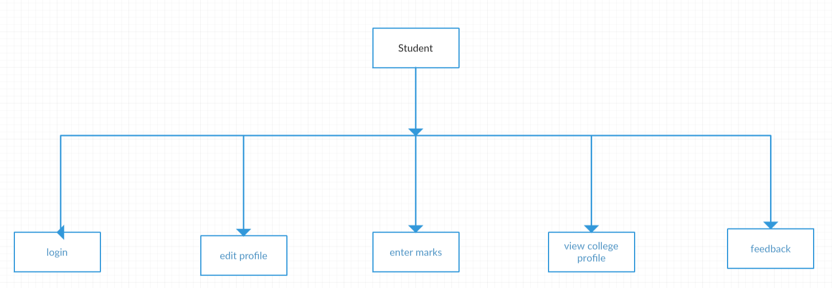

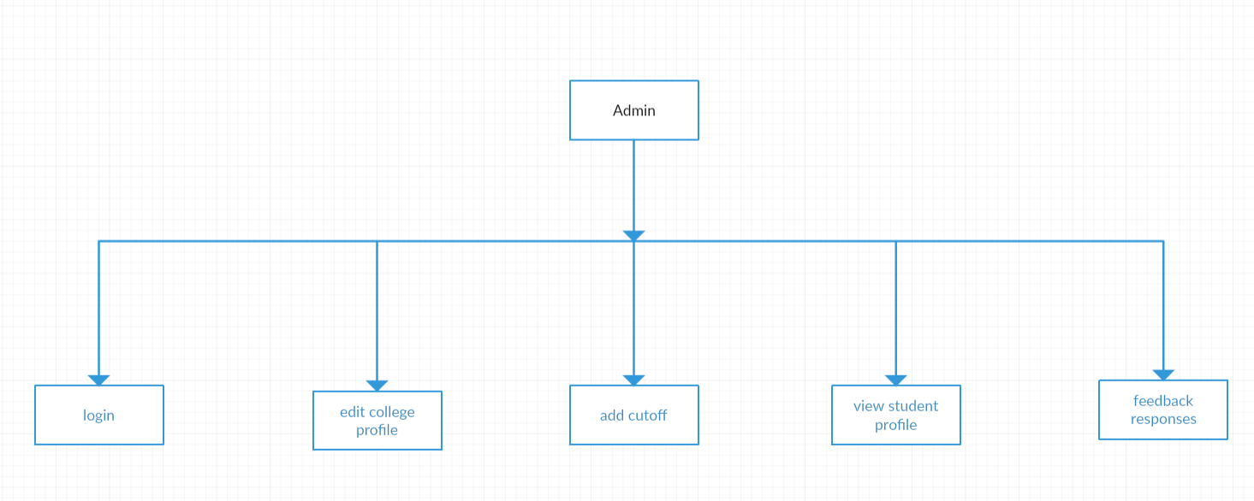

**5. System Requirement Specification:**

5.1 **Functional System Requirement:**

This section gives a functional requirement that applicable to the project.

These are sub modules in this phase.

Administrator module:-

As the student will get colleges and a next year would start, the admin would need to update the cut offs and new information about the colleges, if any. So, it is required for the administrator to remove the previous record from the database tables. This section also includes the option and the deletion of the particular student record from the database.

User Module:-

1. It allows the different users to access the college details.

2. They can view the past year record of different colleges and also view the latest changes done easily.

**The functionality of each module is as follows:**

The system comprises of 2 major modules with their sub-modules as follows:

1. **Admin:** 
   1. **Add College:** Provide details for college like name, address, streams provided etc.
   2. **Add Cut Off:** Select College from database and provide cut off for previous years.
   3. **Manage / View Colleges:** Update details for college and delete them if require.
   4. **View Students:** View list of students registered into the system.
   5. **View Feedback:** View feedback sent by user (student).
2. **Student:**
   1. **Register**: Student will register themselves to the system by providing name, email ID, marks etc.
   2. **View College:** Student will be provided an option to show collegesnear him and will show all the colleges based on his score.
   3. **View Profile:** Can view their own profile details.
      * **Feedback:** Student can send the feedback to notify the admin about the system.

**5.2. Non-Functional System Requirements:**

5.2.1. **Performance Requirements**

* Some Performance requirements identified is listed below:
  + The database shall be able to accommodate a thousand record to store.
  + The software shall support use of multiple users at a time.
  + There are no other specific performance requirements that will affect development.

5.2.2. **Safety Requirements**

The database may get crashed at any certain time due to virus or operating system failure. Therefore, it is required to take the database backup.

5.2.3. **Security Requirements**

* Some of the factors that are identified to protect the software from accidental or malicious access, use, modification, destruction, or disclosure are described below. Keep specific log or history data sets
  + Assign certain functions to different modules
  + Restrict communications between some areas of the program
  + Check data integrity for critical variables
  + Later version of the software will incorporate encryption techniques in the user/license authentication process.

**6. HARDWARE, SYSTEM AND SOFTWARE REQUIREMENT**

* HARDWARE AND SYSTEM:
* Intel based processor-run computer system, which have keyboard and mouse as input devices. This has been decided for its case of availability and up-gradation.
* Ram: 16GB, Storage: 1TB HDD +256 SSD, Graphics: GTX 1050Ti. We require this to sufficiently store the data.
* The various registers maintained at the different department have enough information recording, which will help in digitizing the available data.
* Platform: Windows10. Our system requires window operating system, which is easily available.
* SOFTWARE:
* **Front End**
* Language used: HTML, CSS, JavaScript and PHP.
* **Back end**
* Supporting Software: SQL Server 2005. This is used to storing data in the form of tables. It is easy to use.

**7. DATA FLOW DIAGRAMS (DFDs):**

A data flow diagram is graphical representation that depicts the information flow and the transformations that are applied as data moves from input to output. It can be used to represent a software at any level of abstraction. In facts DFDs may be partitioned in to levels. DFDs are defined in levels with every level decreasing the level of abstraction as well as defining a greater detail of the functional organs of the system.

**0 Level DFD (context level)**

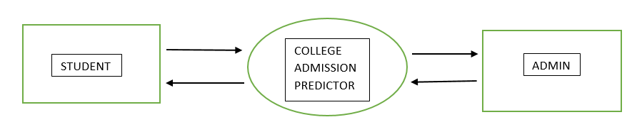

**1Level DFD**

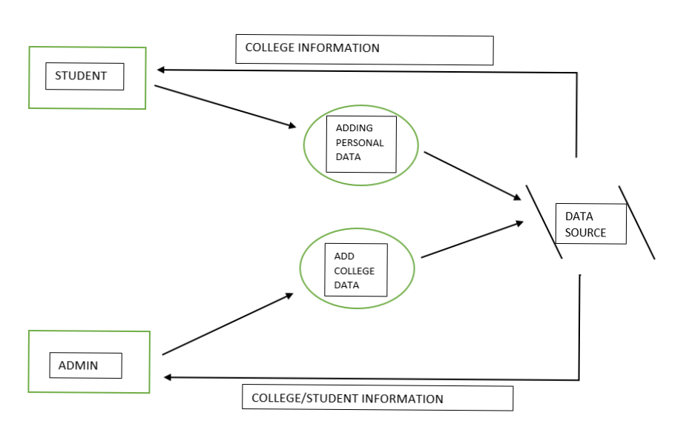

**2 level DFD**

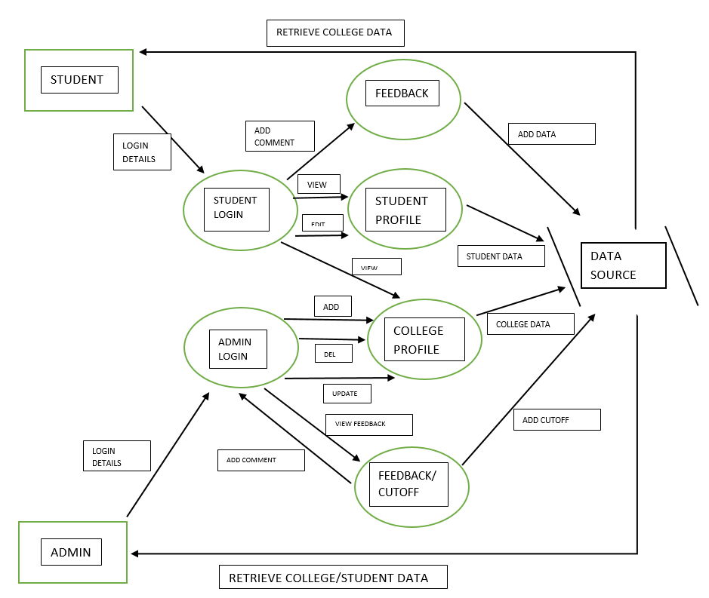

**8. CLASS DIAGRAM**

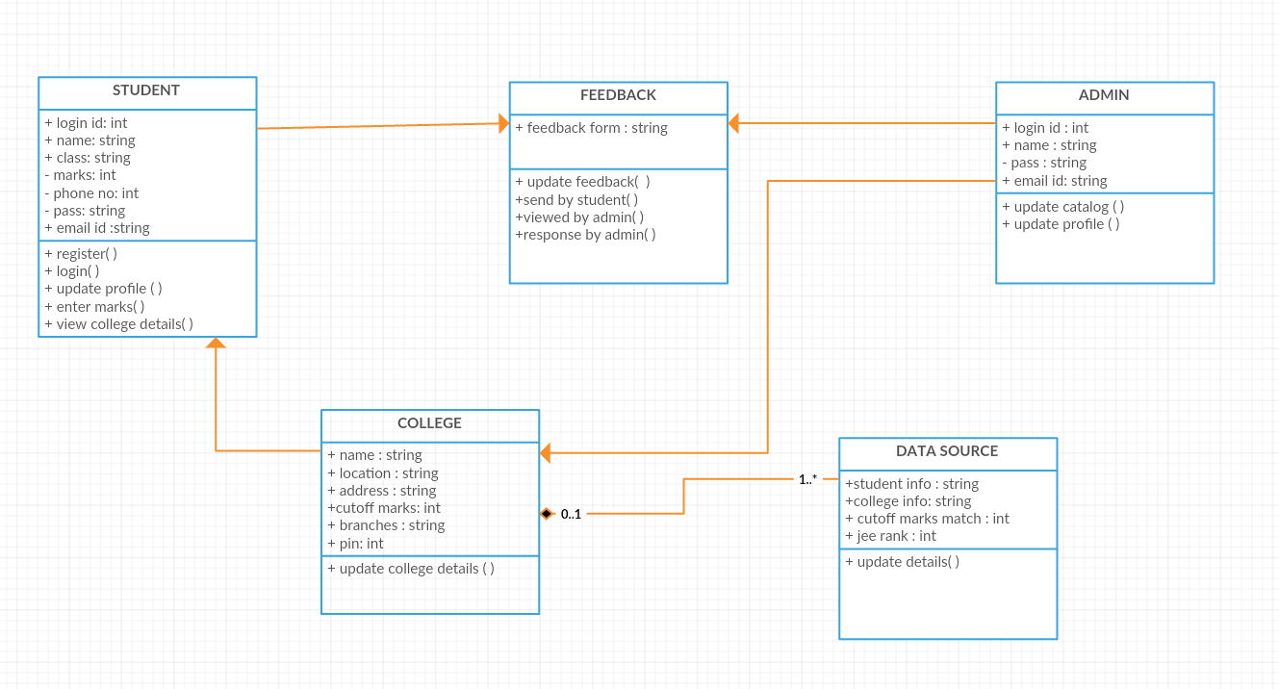

**9. USE CASE DIAGRAM**

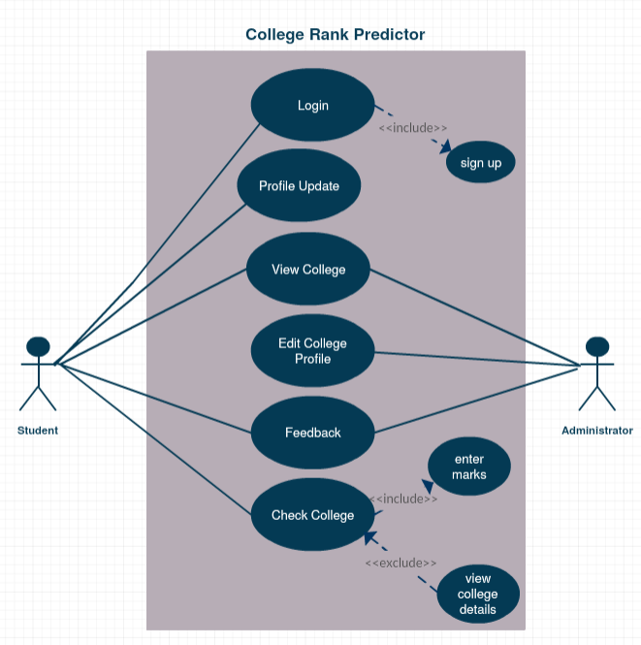

**10. ACTIVITY DIAGRAM**

STUDENT:

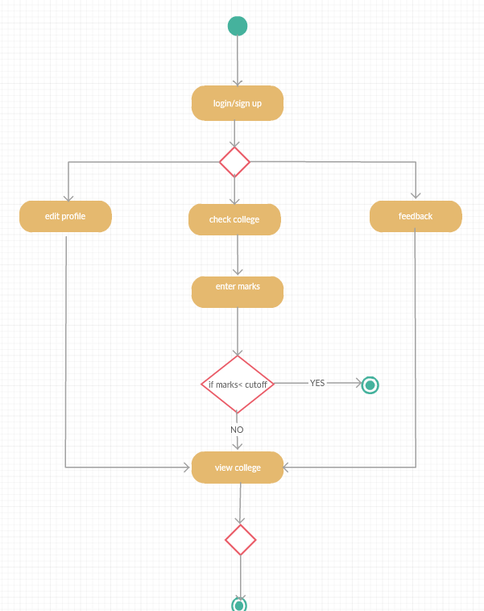

ADMIN:

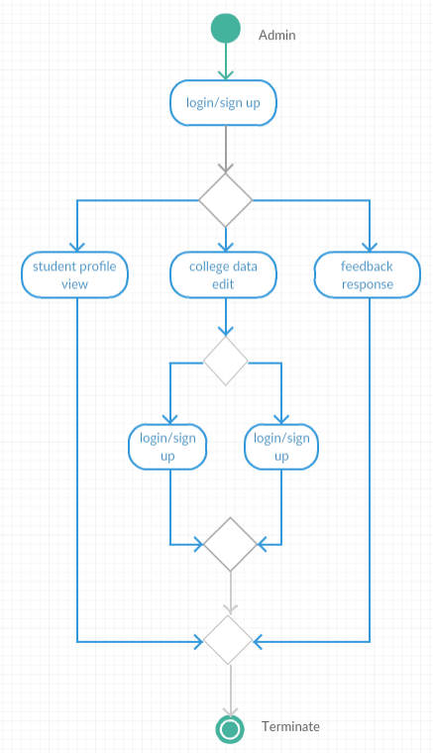

**11. ER DIAGRAM**

